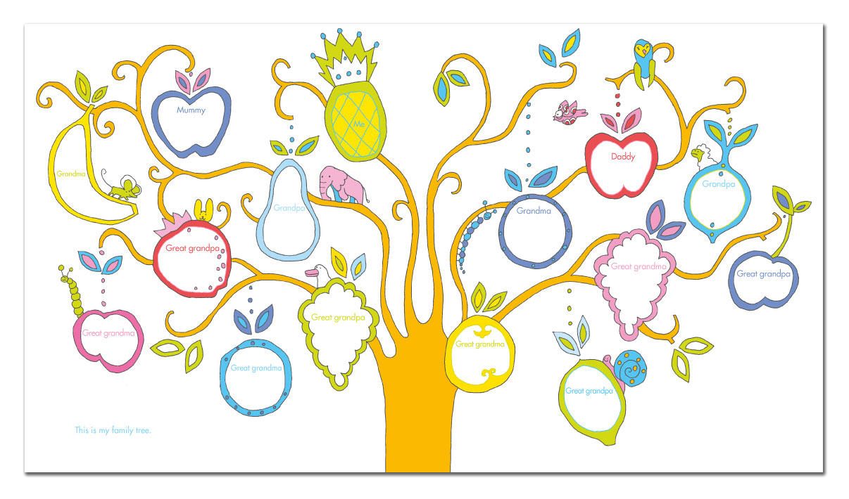[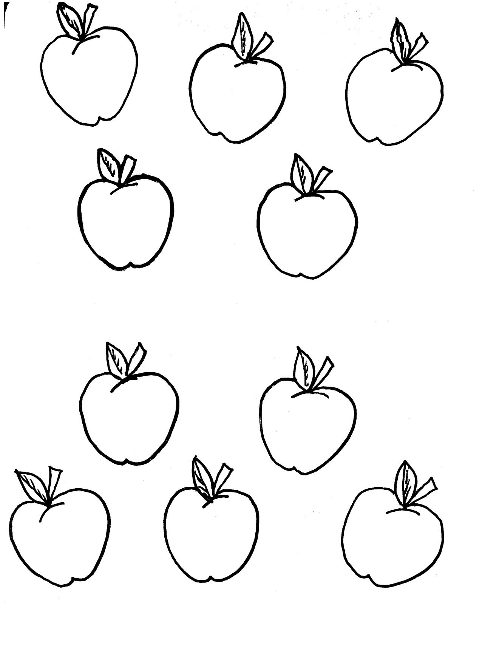](http://www.google.co.uk/url?sa=i&rct=j&q=family+tree+apples&source=images&cd=&cad=rja&docid=QeRXjlGQCB9O5M&tbnid=PQB7fXQmH20sNM:&ved=0CAUQjRw&url=http%3A%2F%2Fkiboomukidscrafts.com%2Ffamily-tree-craft-and-song-for-kids%2F&ei=GRKeUYjRCM7jO_rlgfgH&psig=AFQjCNF8yUJCh4wP0nt5v2ydsNW5eahs-g&ust=1369400131149148)[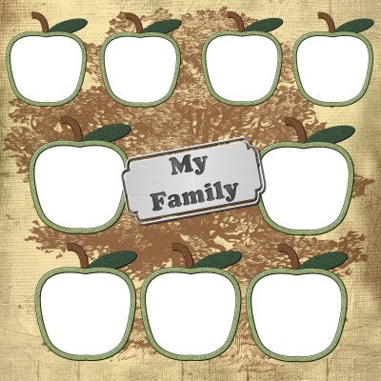](http://www.google.co.uk/url?sa=i&rct=j&q=family+tree+children&source=images&cd=&docid=_fWdcqo-IJzrJM&tbnid=Lu9Kz_QcWuHL3M:&ved=0CAUQjRw&url=http%3A%2F%2Fhumbuggraphicsgalore.blogspot.com%2F2009%2F03%2Ffamily-tree-qp-three-sibling-version.html&ei=XxGeUfq4McLpPJfegaAG&bvm=bv.46865395,d.bGE&psig=AFQjCNHe9-Ax_d2VvUsgP0XfMMdveTfAxQ&ust=1369399896487273)

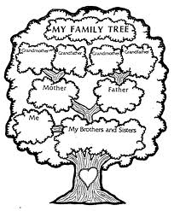

[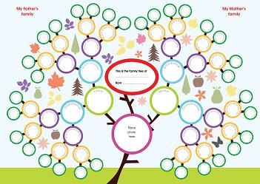](http://www.google.co.uk/url?sa=i&rct=j&q=family+tree&source=images&cd=&cad=rja&docid=vrURw1Y3Fl7uHM&tbnid=nW2iSmvJGHpNlM:&ved=0CAUQjRw&url=http%3A%2F%2Fwww.ancestryuk.co.uk%2Fhow-to-make-a-family-tree.html&ei=kQ-eUa3pHoTiOveZgagH&bvm=bv.46865395,d.bGE&psig=AFQjCNGkYDUs39kxfUwgvU7Fval8BUF-LA&ust=1369399546678557)