Blessing over the Children

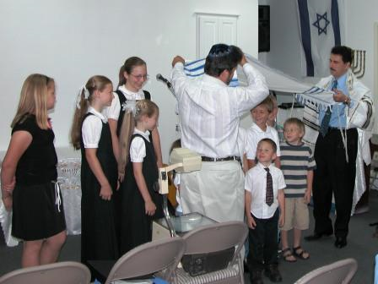

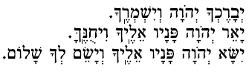

Y'varechecha Adonai V'yish'm'recha.
Ya'er Adonai panav eilecha vichuneka.
Yisa Adonai panav eilecha v'yasem l'cha shalom.

May God bless us and guide us. Let us seek truth, make peace, be kind and courteous in our words, just and loving in our deeds. A noble heritage has been entrusted to us; let us guard it well.

May God bless you and keep you.
May God look kindly upon you, and be gracious to you.
May God reach out to you in tenderness, and give you peace.

