David Beckham Biography
A profile of David Beckham, the shy boy who became the world's most famous football player.
David Robert Joseph Beckham was born on the 2nd of May 1975, in Leytonstone, London, England, and if this was a movie commercial, I guess it would say: "He was born to be a soccer player!" - Because that is what he always wanted to be.
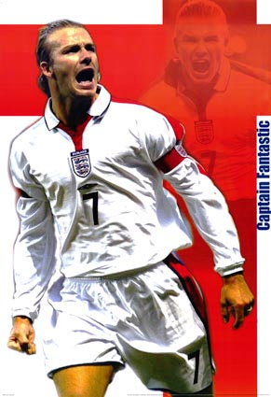
His talent was obvious at an early age, but talent alone is not enough, because the world is full of talented people who didn't become anything. But his father would make sure David's talent wasn't wasted, as he was doing a lot of practicing with his son, especially passing and crossing the ball - the very trademark of Beckham today: the pinpoint accurate crosses.
All this training was soon to pay off. In 1986, aged 11, David Beckham won a Bobby Charlton Soccer Skills Award. The trophy was presented at Old Trafford; a place that would later become like another home to David. Also included in the prize for winning the Soccer Skills Award was a trip to FC Barcelona to train with them for two weeks under Terry Venables, Barcelona’s coach at that time.
The Dream Comes True
Naturally, Beckham's talent didn't go unnoticed for long and he was invited to have trials with Leyton Orient and Tottenham Hotspur's School of Excellence, but it was Manchester United that was the lucky winner in securing the signing of David Beckham as a trainee in 1991. And actually, Alex Ferguson was the main reason for David choosing Manchester United instead of Tottenham, because when David came to United, the first thing that happened was that Alex Ferguson came over to him and said "hello David".
So, aged 16, David Beckham moved to Manchester, where he was part of Manchester United's famous youth team which won the FA Youth Cup in 1992.
The Youngster
In order to toughen him up a bit and give him more experience, Beckham was loaned out to Preston North End in division 3 for a few weeks in March 1995 where he played 5 matches and scored 2 goals.
He returned to Manchester United in April, and Alex Ferguson thought David Beckham was ready for the Premier League. David made his Premier League debut in the match against Leeds on April 2, 1995.
Makes his Mark
In the following season, 1996/1997, Beckham made sure that he meant business already in the first match of the season, when he scored against Wimbledon from the half way line. That goal was shown in television over and over again, and David Beckham was now a household name in England. Manchester United again won the Premier League that season.
Both Beckham and the rest of the Manchester United team produced some spectacular football over the next three years, and in late May 1999, United had won the treble: The Premier League, the F.A. Cup and the Champions League. And Beckham had been one of the very best players.
He also became father to his first son in March 1999 and married Victoria Adams (Posh Spice) in July. In 2000 Beckham was named as captain of the English national team.

