OFFICIAL NATIONAL ISRAELI EMBLEM
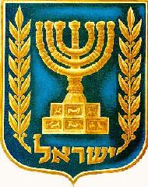

Look at the Emblem with a partner and discuss the questions below:

1. What are the three things you see in the emblem?

2. What does the Hebrew writing say at the bottom of the symbol?

3. The olive branch is a symbol of peace; explain why you think the olive branches are on the emblem?

4. What is the link between the menorah and the olive/ olive branches?

