Jack and the Beanstalk
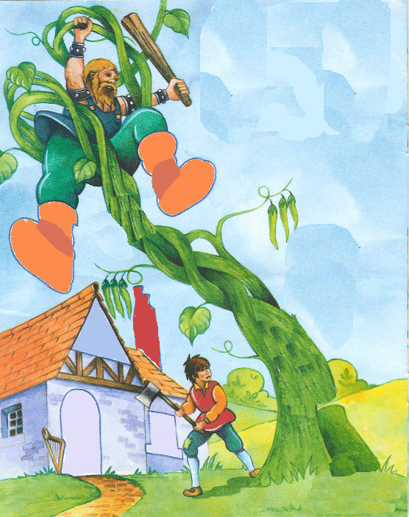
Jack climbed up a giant’s magic beanstalk. “Fee, Fi, Fo Fum.” Jack stole the giant’s golden hen and harp and ran down the beanstalk before the giant could catch him.

Goldilocks and the Three Bears
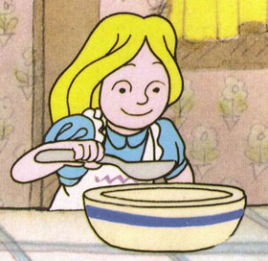
Goldilocks ate three bowls of food, sat and slept in three places. The three bears came back, found their food, chairs and beds used and were very angry with Goldilocks.

