Jerusalem - The Western Wall

The Western Wall is the last remaining wall of the Second Jewish Temple. Built approximately 2500 years ago, the Second Temple was the centre of the Jewish people’s national and religious life. Three times a year, Jews from all over Israel came to the Temple to visit it and pray there. Today Jews from all over the world visit the Western Wall. Many will place a small note in between the stones of the wall, as Jews believe that what is written on the note will go directly to God.

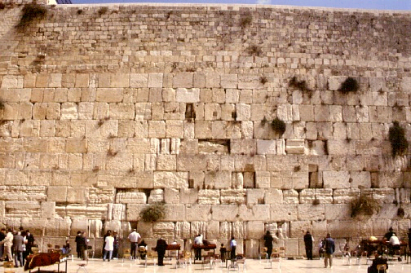

Let’s read the following story:
“Where are we going today, Mum and Dad?” asked Tali.
“We are going to visit the holiest part of Jerusalem” answered Dad “Just follow me through these narrow streets of the Old City and soon we will be at the Western Wall.
“There it is”, yelled Benjy, Tali’s brother. “It’s that huge wall in front of us. Can we get close to it?”
“We sure can. Let’s go,” answered Mum.
Benjy and Tali walked up to the wall and put their hands on the warm stone blocks. They recited the ‘Shema’:
Shema Yisrael A-donai El-oheinu Adonai ehad
"Hear O Israel, the Lord is our God, the Lord is One"
Then, they started writing their notes on a small piece of paper. “What are you going to pray and wish for, Tali?” asked Mum. “I am praying for our family to be happy and healthy, and for Israel to have peace,” answered Tali.
“And what are you wishing for, Benjy?” asked Dad.
“I am going to pray to have my Bar Mitzvah here,” answered the very happy and excited Benjy.

