Joshua and the Walls of Jericho
There was a city close to the Jordan River.
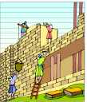
The city's name was Jericho.
There were huge walls around the city.
The people of Jericho had heard what happen on the Jordan River and they became afraid of the Israelites.
They locked up their gates tightly, not allowing anyone in or out of the city.
The Lord said to Joshua, "I will help you get into the city. Your army is to walk around the city once a day for six days followed by seven priests walking ahead of the Ark. On the seventh day, you are to walk around the city seven times with the priests blowing trumpets. All the people are to shout loudly. The walls will fall and then you can go in."
Joshua called the army together and told them what the Lord had said.
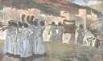
Every day at dawn, for six days, the army left the camp.
They walked around the city followed by the priests walking ahead of the Ark.
On the seventh day, at dawn they left the camp as usual.
On this day, instead of walking around the city one time, they walked around seven times.
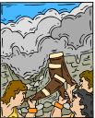
The army first, followed by the priests with their trumpets, walking ahead of the Ark.
After they had walked around the seventh time, the priest gave a loud blast on their trumpets.
Everyone shouted as loudly as they could: "The Lord has given us this city."
With that the walls began shaking, crumbling and tumbling down.
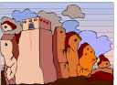
The people inside were so alarmed!
They didn't know what to do.
They began running.
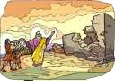
They scattered everywhere.
The Israelites just walked into the city.
God was with them.

