Adam and Eve had two sons, Cain and Abel. | Cain was a farmer and Abel was a shepherd. | Abel sacrificed the best lamb he had, but Cain chose some left over hay. Guess whose sacrifice burnt properly and whose did not? | Cain was angry...And so he asked Abel to go for a walk with him...
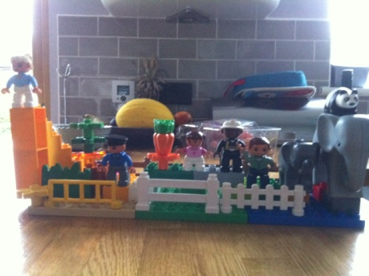 | 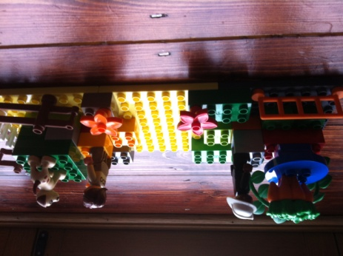 | 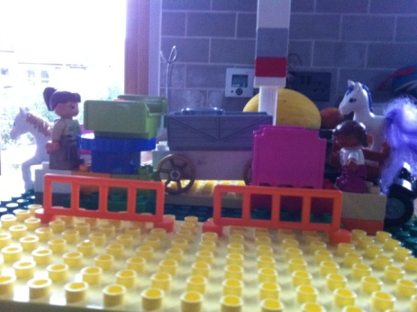 | 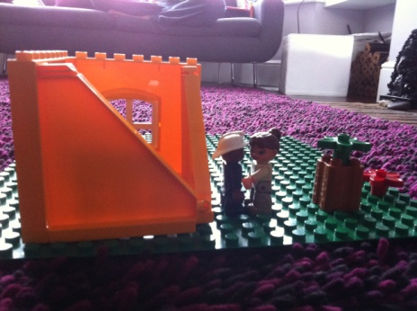
‘You always have to be the best one, everyone’s darling’ Cain yelled at Abel. | Cain was so so angry that he hit Abel and killed him. | And then God asked Cain ‘Where is your brother Abel? What have you done to him?’ | And then Cain realised the bad thing he had done, and he wished everything was as it used to be...
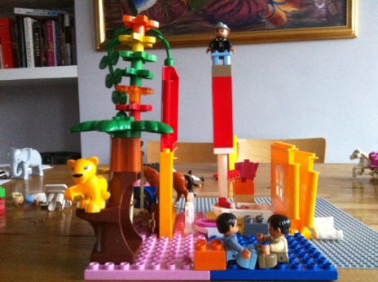 | 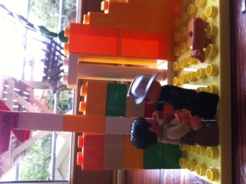 | 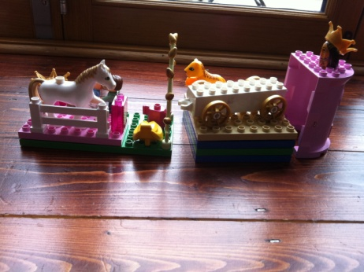 | 