Noah's Ark

Noah had 3 sons called Shem, Ham and Japheth. When Noah was alive, all the people of the earth were very bad. They stole, and were rude, and were criminals and weren't good people. God became angry at all the people because they didn't live in the way that God told everyone that they should. God was so mad, he wished that he never made people at all. So, God decided to have a big, big flood to kill all of the bad people. But he would save the only good people left, which was Noah and his family.

God told Noah to build a very big boat, called an Ark, and that it had to be made out of Gopher wood. It had to be a really big boat. Big enough for Noah and his wife. And their three children. And two of every animal that is unclean (that isn't kosher) (like pigs, dogs and bears) and seven of every animal that is clean (kosher) (like chicken, sheep or cows).

It took Noah a few years to finish building the ark, it was that big. Then, all of the animals went into the ark safely with Noah and his family, and they were shut in. Then, God sent a rain that lasted not for one day, not for two days, but for 40 days!

The water became higher, and higher, and higher! It went so high that you couldn't even see the top of Mount Everest! Only Noah, his family, and all the animals that were in the Ark were saved. Of course the fish of the sea were probably quite happy!

The ark floated on the water for roughly seven months, until it got stuck on the mountains of Ararat. It stayed there until the tops of the mountains could be seen. Noah waited, and then he sent out a raven and a dove to see if they could find anything. The raven flew to and fro, but the dove after a while, returned with an olive branch. Noah waited another week, and sent out the dove, but it didn't not come back.

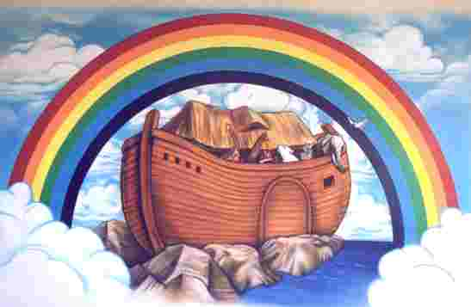
When the land was dry, God told Noah to leave the ark. Noah offered a sacrifice to God, and God said he'll never again curse the earth. Then God and Noah entered a deal called a “covenant”, and put a rainbow in the clouds.

