Shabbat

Objects and Meanings of Shabbat

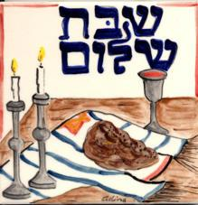
Shabbat is the most important ritual
observance in Judaism. It is the only
ritual observance instituted in the
Ten Commandments. It is also the
most important special day, even
more important than Yom Kippur.

The first mention of Shabbat is found
in the Torah in the Book of Genesis.
After the six days of creation, God
rested. From this earliest description
of Shabbat, we learn that a central
theme of Shabbat is to separate it
from the rest of the week.

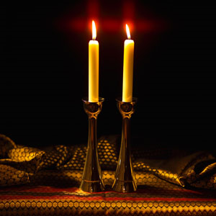
Candles and candlesticks:

We light the candles and recite a blessing to usher in the beginning of Shabbat.
The light of the candles make us think of the light that Shabbat brings into our lives.

Kiddush Cup:
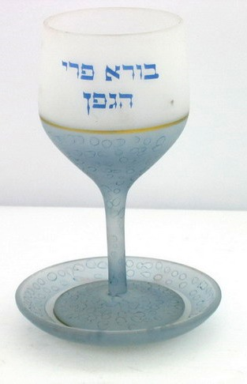

Kiddush means “Sanctification” and is the
name given to the first blessing we say at
the Shabbat meal, the blessing over the
wine or grape juice. The wine is used as
a symbol for making the Shabbat holy.
Wine is a symbol of joy, happiness, and
luxury, all of which makes us remember
that Shabbat is a holy day and different
from all other days.

Challah:
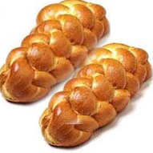
The Shabbat meal truly begins with HaMotzi, the blessing saying thank you for bread.
As the “servant of life,” bread represents all the foods we eat. By beginning a meal with words of thanks, we focus on eating as more than just filling our bellies, but something we should be grateful for.
We have two challot to represent the extra portion of manna (food sent by God when the Jews were wandering the desert – God sent two portions of manna on the eve of Shabbat so that the Jews did not need to find food on Shabbat). We add salt to the sweet Challah to make sure that we enjoy a sweet Shabbat, but also remember the bitterness of our past.
We cover the challah with a cloth and lay it on a board. This is because when the manna fell in the desert it was covered in a layer of dew on top and underneath. .

