Pesach Crossword

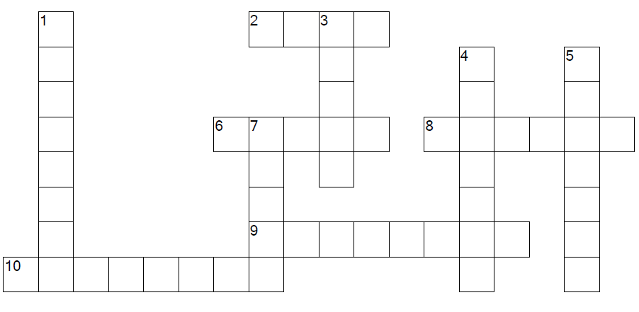

ACROSS
2. Sacrificed, blood smeared on the doorpost of every Jewish house
6. The festive meal held on the first nights of Passover
8. Unleavened bread
9. Jewish holiday celebrating the exodus of the Israelites from Egypt
10. Apple, nut, spice and wine mixture

DOWN
1. Book with the story of the Exodus and the ritual of the Seder
3. Led the Israelites out of Egypt
4. Ten afflictions on Egypt
5. Ancient Egyptian king
7. Ancient empire on the Nile River and ruled by a Pharaoh

Pesach Challenge
1. The festive meal held on the first nights of Passover
A. Moses B. Seder C. Plagues D. Pharaoh
2. Jewish holiday celebrating the exodus of the Israelites from Egypt
A. Moses B. Passover C. Charoset D. Egypt
3. Sacrificed, blood smeared on the doorpost of every Jewish house
A. Lamb B. Passover C. Plagues D. Haggadah
4. Ten afflictions on Egypt
A. Pharaoh B. Moses C. Matzah D. Plagues
5. Led the Israelites out of Egypt
A. Matzah B. Pharaoh C. Moses D. Haggadah
6. Unleavened bread
A. Moses B. Plagues C. Matzah D. Passover
7. Ancient Egyptian king
A. Egypt B. Passover C. Seder D. Pharaoh
8. Book with the story of the Exodus and the ritual of the Seder
A. Seder B. Haggadah C. Pharaoh D. Moses
9. Apple, nut, spice and wine mixture
A. Moses B. Pharaoh C. Matzah D. Charoset
10. Ancient empire on the Nile River and ruled by a Pharaoh
A. Egypt B. Haggadah C. Pharaoh D. Seder

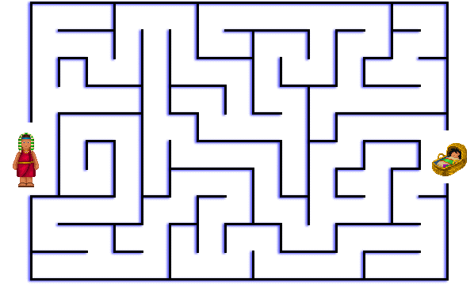
Help Moses Down the River to Pharaoh’s Daughter

Pesach Word search
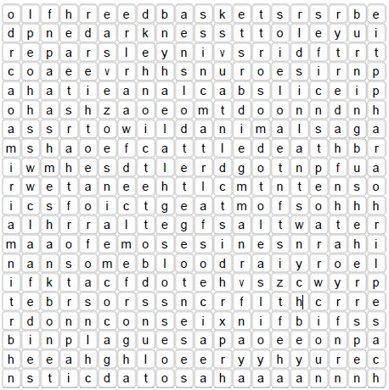
Words to find:
- Aaron | - Miriam
- Blood | - Moses
- Boils | - Parsley
- Burning Bush | - Pesach
- Cattle Death | - Pharaoh
- Charoset | - Plagues
- Darkness | - Reed Basket
- Death of the First Born | - Reed Sea
- Frog | - Roasted Egg
- Hail | - Salt Water
- Lice | - Seder
- Locusts | - Shankbone
- Marror | - Wild Animals
- Matzah

