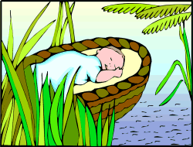
When Moses was born the Hebrews were slaves in Egypt. Pharaoh was afraid of them because he thought they might take over his country. He ordered that all Hebrew baby boys be killed at birth so that they would not grow up and fight against him. To save Moses his mother made a plan. She hid him in a basket by the side of the River Nile.

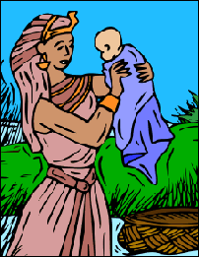

Moses' sister Miriam watched over him until Pharaoh's daughter came to the river to wash. She found Moses in his basket. Miriam told her she knew a woman who could be a nurse for the baby. It was his mother. Pharaoh's daughter took him back to live with her as though he were her son.
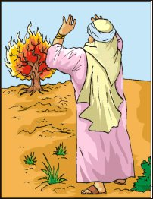
Moses grew up as an Egyptian prince, but he never forgot he was a Hebrew. One day Moses lost his temper and killed an Egyptian who had beaten a Hebrew slave to death. He had to run away to another land. God spoke to him from a burning bush and told him he must go back and free the Hebrews from slavery.
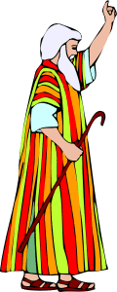

Moses went to Pharaoh after finding his brother Aaron to ask him to set the Hebrews free. Pharaoh did not want to lose his slaves. He would not let them go, because they worked on his grand buildings. Awful things began to happen in Egypt. There were ten plagues. Before each one, Moses had warned Pharaoh what would happen. Moses told him the disasters had been sent by God.
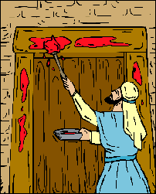

The last plague was the worst. The eldest son in every Egyptian family, including Pharaoh's, died. God had warned Moses to mark the doorposts of all Hebrew houses so that Hebrew boys would be safe. Pharaoh was so upset by losing his son that he said the Hebrews could leave Egypt.

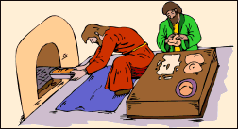

The Hebrews knew they must leave Egypt quickly. They needed food to take with them. There was no time to let the bread rise before it was cooked. They had to take the dough as it was. Pharaoh changed his mind again and sent his army after them to bring them back.
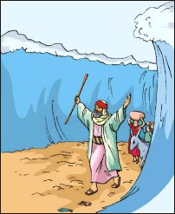
The army chased the Hebrews to the banks of the Red Sea. They would have been trapped but a miracle happened. God told Moses to lift up his rod and as he did so the waters parted to make a dry path. They were able to make their escape.

