Priceless at Twice the Price
(Adapted from You Be the Judge, Joel Lurie Grishaver, Torah Aura Productions, 2000)

Zoe and her mother love car-boot sales. They are very good at finding real treasures among the junk. One day they are hunting at a car-boot sale round the corner from their house. They find themselves at Debbie and her mother’s stall. Zoe and Debbie are in the same class at school. Zoe and her mother find a vase on sale for 75p. Zoe’s mother knows that it is worth hundreds of pounds because it is a signed piece from a famous designer. The next day at school, Zoe tells Debbie in a nice, not a mean way, what a good buy the vase was. That afternoon, Debbie’s mother calls up Zoe’s mother and demands the vase back. She says, “You cheated me and bought it way too cheaply.” Zoe’s mother says, “I bought it for the price you asked.”
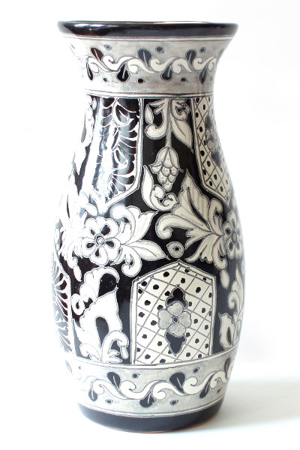
YOU BE THE JUDGE: What is fair and Just here?

Priceless at Twice the Price

The Interpretations
The question is whether or not Zoe and her mother have cheated Debbie and her mother when they bought the vase for only 75p.

In Maimonides, The Laws of Acquisition, we learn:
- That both a buyer and a seller must be honest in transactions. Neither can cheat or defraud the other (12.1).

- Making more than 20% profit on something is considered dishonest, and the laws of fraud say that the deal should be cancelled or the difference (up to 20%) should be repaid (12.4).

- These rules of unfair profit apply only to necessities of life, things like food, clothing etc... When it comes to luxuries, a buyer and seller may charge and pay what they want (14.2).

The Answer?
Vases are luxuries, so the deal is legal (if not fair). Zoe’s mother can keep the vase (but Zoe may lose a friend).

Question: What is ‘fair’ and what does ‘fair’ mean?

