Rosh Hashanah Objects

Apple and Honey
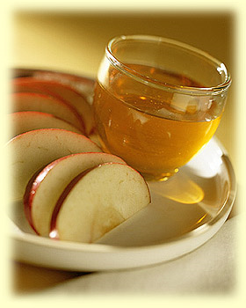
On Rosh Hashanah we eat apples dipped in honey. The apples remind us of the roundness of the year and tell us that the coming year will be fruitful. The honey represents the wish for a sweet year. Some people dip bread in the honey as well, hoping that the New Year will be just as sweet as the bread.

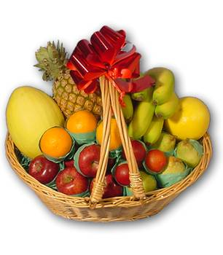
New fruit

On Rosh Hashanah we taste a fruit that we have not yet eaten during the year. We say “Shehecheyanu”, the blessing we recite for new things. This new fruit is considered good luck.

Fish Head
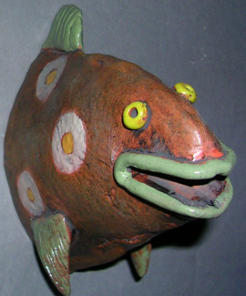

Some people eat a fish head, saying the blessing “May we be like a head (leader) and not a tail (follower)”, or “We will be fruitful and multiply like fish”.

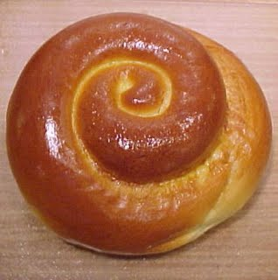
Round Challah

We eat round challah instead of the usual plaited challah that we eat on Shabbat to signify a long life and a smooth year. Challah for Rosh Hashanah is often made with either a sweet dough, or sweet fruit, such as raisins baked into it.

Pomegranate
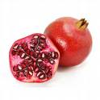

The 613 seeds of the pomegranate represent the number of good deeds (mitzvot) which we have attempted to do over the past year and should do during the New Year.

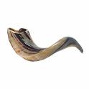
Shofar

The Shofar is the most important symbol of Rosh Hashanah. We sound it on both days of the festival. We blow the Shofar with four different calls:

- Tekiah – one long sound
- Shevarim – three shorter blasts
- Teruah – nine fast toots
- Tekiah Gedolah – a long blast, if possible 27 beats long!

Wearing white

Many people wear white on Rosh Hashanah because white symbolises purity and our desire to be close to God. A white robe also reminds us of the white robes worn by angels. Some people will wear trainers or soft shoes as a tradition is to not wear leather.

White in the synagogue

The curtain across the ark is changed to a white one and the Torah covers are changed to white. This is to show that "our mistakes will be whitened like snow."
