Rosh Hashanah song
(To the tune of My Darling Clementine)
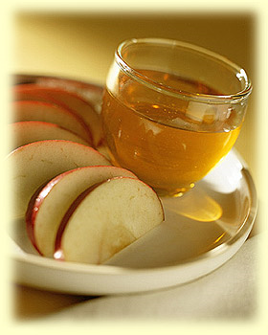
Dip the apple in the honey
Say the bracha loud and clear
L’shanah tovah O’metuka
Have a happy, sweet new year

Rosh Hashanah song
(To the tune of My Darling Clementine)
Dip the apple in the honey
Say the bracha loud and clear
L’shanah tovah O’metuka
Have a happy, sweet new year

Rosh Hashanah song
(To the tune of My Darling Clementine)
Dip the apple in the honey
Say the bracha loud and clear
L’shanah tovah O’metuka
Have a happy, sweet new year

Rosh Hashanah song
(To the tune of My Darling Clementine)
Dip the apple in the honey
Say the bracha loud and clear
L’shanah tovah O’metuka
Have a happy, sweet new year

