Blessing over the Candles

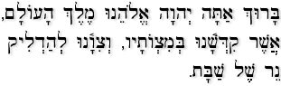

Baruch Atah Adonai Eloheinu Melech ha-olam,
Asher kid’shanu b’mitzvotav v’tzivanu l’hadlik ner shel Shabbat.

We praise You, Adonai our God, Sovereign of the universe, who has sanctified us through Your commandments and commanded us to kindle the Shabbat lights.
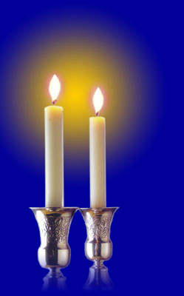
Blessing over the Wine

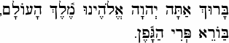

Baruch Atah Adonai Eloheinu Melech ha-olam,
borei p’ri hagafen.

We praise You, Adonai our God, Sovereign of the universe, who creates the fruit of the vine.

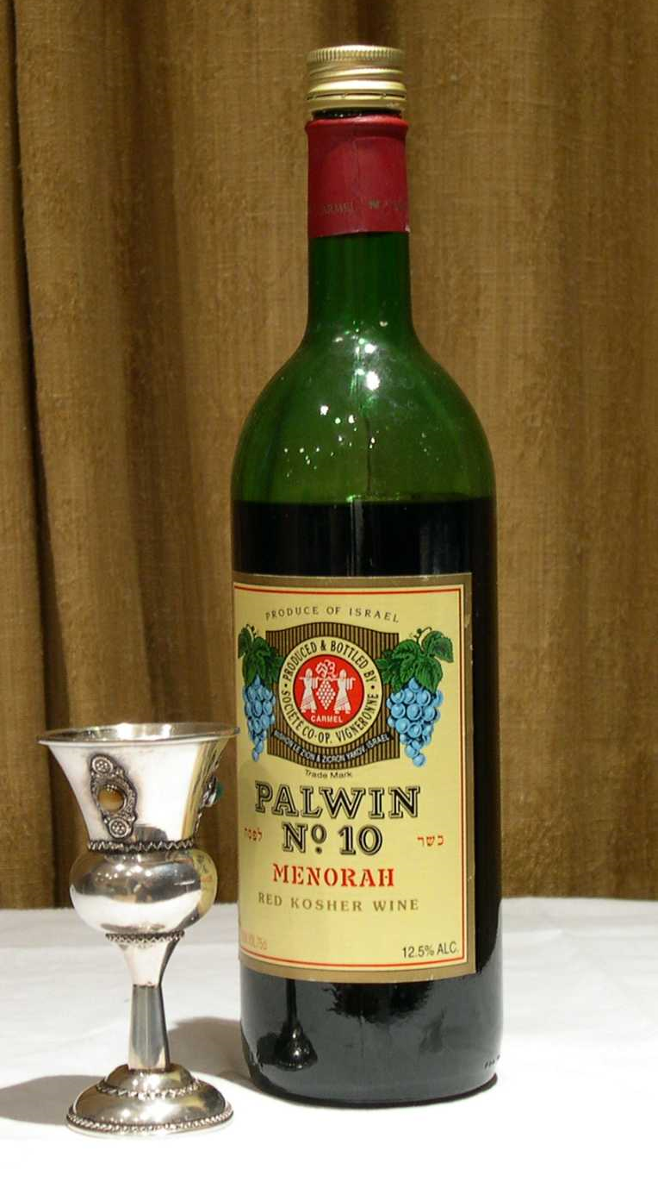
Blessing over the Challah

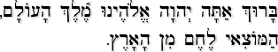

Baruch Atah Adonai Eloheinu Melech ha-olam,
hamotzi lechem min ha-aretz.

We praise You, Adonai our God, Sovereign of the universe, who brings forth bread from the earth.
