Abraham and Sarah

Abraham and his wife Sarah lived a long time ago in a town called Haran. They lived with Abraham's father Terach and his family. Terach had a store where he sold idols, which were statues that people bowed down to and called gods. This made Abraham really sad. He knew that it was wrong to worship idols. He tried to teach his father and neighbours that it was silly to bow down to idols and that only God is God. But most people didn't want to listen.

One day when Abraham and Sarah were already getting old, something amazing happened. God came and spoke to Abraham. He had never done this before and Abraham was quite surprised. But he was even more surprised by the incredible things that God told him.
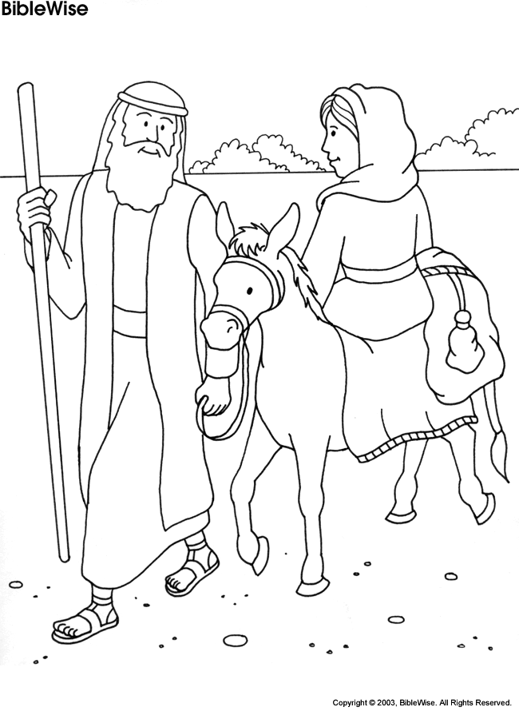

He said, "Abraham, I want you and Sarah to leave your father's house and leave the land you were born in. I want you to come with Me to where I'll take you. I'm going to make you into the father of a great nation. The whole world is going to know about you, and learn from you that I am God."

Abraham didn't know what to say. He thought, "How am I going to just leave everything and everybody behind? What about my family and friends? What will people think? But if God wants me to go and to teach the world what I know is true, then I'm sure it's the right thing to do." So without wasting any time, Abraham and Sarah packed their things and began an exciting journey into the unknown.

