Ezra brings the Torah to the People
On the first day of the seventh month, the entire people assembled in the square before the Water Gate and Ezra the scribe brought the Torah – the teaching of Moses - before the people: men and women and all who could listen with understanding. He read from it from dawn to midday. Ezra opened the scroll in the sight of all the people, for he was above all the people (standing on a wooden tower) and all the people stood up. Ezra blessed the Eternal and all the people answered “Amen”. Then the priests and the Levites explained the Torah to the people while the people stood in their places. They read from the scroll, translating it and giving the sense so they understood it. And all the people were weeping as they listened to the words of the Torah. But Nehemiah and Ezra said “This day is holy to the Eternal: you must not mourn or weep. Go and eat choice foods and sweet drinks and send portions to anyone who has nothing prepared for the day is holy to God. Do not be sad for your rejoicing in the Eternal is the source of your strength.”
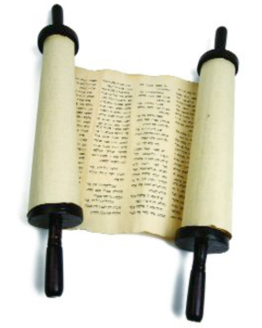

The Most Important Commandments?
Over the next few months the people observed the festivals and continued to learn Torah. Then Ezrah made this pledge:
“We, the heads of the people, the priests and Levites, the gatekeepers, the singers, the Temple servants and all who follow the teaching of God, their wives, sons and daughters, all who know enough to understand, join with their noble brothers and sisters to take an oath to follow the Teaching of God, given through Moses, the servant of God and to observe carefully all the commandments of the Eternal, the rules and the laws.
1 We will not give our daughters in marriage to the peoples of the land, or take their daughters for our sons.
2 We will not buy goods or food on Shabbat or a holy day.
3 We will make donations to the House of our God.
4 We will bring wood offerings to the House of God to provide fuel for the altar.
5 We will bring the first produce from the ground and first fruits of every tree annually to the House of God.
6 We will not neglect the House of God.

