The Story of Isaac and Rebekah

A very long time ago, God made a promise to Abraham. God kept his promise by giving Abraham a son named Isaac. When Isaac was forty years old, Abraham decided it was time for Isaac to marry. Abraham kept Isaac at home and sent his oldest servant to find a wife for Isaac and bring her back. He wanted a wife for Isaac who knew the true God, who was from his own people. The servant left Hebron and travelled over 500 miles to Abraham's home city of Haran. He took ten camels and everything he needed for the long journey. It probably took two months to get there. When he arrived it was late in the day. He stopped at a well just outside the city. He prayed and asked God to show him who to choose.

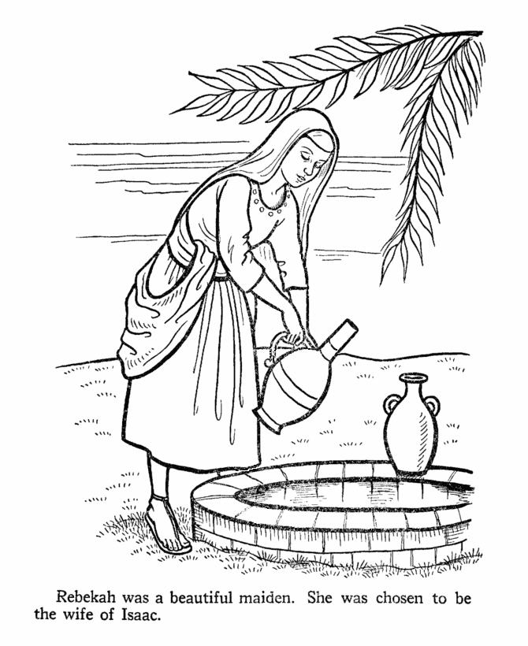
Abraham's servant had not even finished praying when a beautiful young woman named Rebekah came to the well. Rebekah gave him water to drink. Then she offered to fill the trough with water for his camels. Wow! Rebekah had shown that she was extremely kind and also a hard worker because ten camels can drink a lot of water! Then the servant gave her a gold nose ring and two gold arm bracelets for her kindness and asked for a place to stay the night. Rebekah ran home and got her brother Laban to come back with her to the well. Then they invited Abraham's servant home to meet her father Bethuel. They all sat down to eat and the servant told what had happened and how God answered his prayer.

Rebekah listened as Abraham's servant explained he was on a mission to find a wife for his master's son, who was a wealthy man, blessed by God. He asked Rebekah's father and brother for permission for Isaac to marry Rebekah. Bethuel and Laban gave their approval and the next day Rebekah left to return with the servant and meet the man she would marry.

A few months later back in Hebron, Isaac was in the field at sunset spending some quiet time with God. He had waited patiently for nearly four months while the servant was gone. He must have been happy to see the caravan of camels coming home, hoping to meet his bride! Rebekah saw a man waiting across the field. She was so excited that she slid down off her camel. Somehow she knew it was Isaac even before she asked who it was. She covered her face with a veil so he would be surprised at how pretty she was later on their wedding day. They fell in love and lived happily ever after.

