The Story of Jacob and Esau

Abraham’s son, Isaac, grew up and married a woman named Rebecca. When it came time, Rebecca had twins. Sometimes twins look alike, but not always. These babies looked different. The first baby was reddish in color. He was very hairy too. They named him Esau. The second baby was born holding onto Esau’s foot. So they named him Jacob (which means grabber). Esau loved to hunt and work outside in the fields. Jacob stayed inside the tents and cooked.
One day Esau came into the tent. He was very hungry. Jacob was cooking a delicious vegetable soup. Jacob decided to do something sneaky. He told Esau that he could have some soup if he gave Jacob his rights as the firstborn son. Esau was so hungry that he did it!
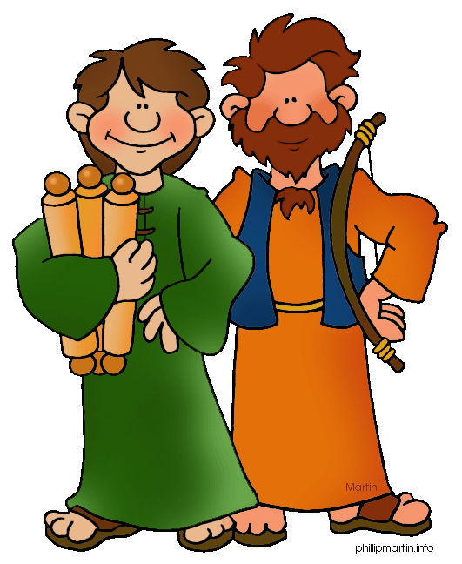
Years later their dad, Isaac, was very old. It was the custom to “bless” the oldest child before the father died. So, Isaac called Esau and asked him to prepare a special meal. Their mum, Rebecca, was listening in the other room. She thought to herself, “I have a plan. I must find Jacob.” So Esau went off into the fields to find an animal and prepare a meal. Rebecca rushed to Jacob and gave him some special instructions so that he could get the blessing instead of Esau. Rebecca was going to deceive Isaac. That means she was going to trick him. They quickly cooked the meal for Isaac. Jacob told Rebecca that he couldn’t fool his dad because Esau was very hairy and he wasn’t.
Rebecca had an idea. She told him to put on his brother’s clothes and put a piece of goat skin on Jacob’s arms and chest because goat’s hair was long, like his brother’s hair. Jacob went into his father. His father was almost blind so he couldn’t tell if it was Jacob or Esau. When he listened, he thought that it was Jacob so he asked him to come close. He felt his hands (which were covered with goat hair) and smelled his clothes (which were Esau’s clothes) so he thought that it was Esau. Jacob fooled his father. Isaac ate the tasty food and blessed Jacob—thinking it was Esau. Just as Isaac finished blessing him, Esau walked in. He was so upset!

A blessing was so important for a child. It showed how special they were and that their family loved them very much. It was so crushing that Jacob stole Esau’s blessing. And remember—Jacob also stole Esau’s birthright as the oldest child. Esau was very mad. In fact he was trying to kill Jacob. Rebecca heard what was going on and told Jacob to leave and live with his uncle.

Years passed without Jacob seeing Esau. During that time Jacob changed his ways. He stopping being tricky and cunning and started following God.
One day it came time for the brothers to meet. Jacob was very nervous about it. He wasn’t sure what his brother would do. In fact he sent his wife and children ahead of him to make peace. Finally Esau saw Jacob. He rushed to him and hugged him. He totally forgave Jacob for everything wrong that had happened.

