Moses Parts the Read Sea
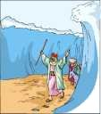
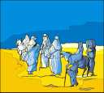
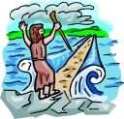
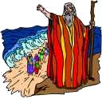
There were many Hebrews that left the city in Egypt.
Through Moses, God led them.
They traveled for many days.
Pharaoh was thinking of how he had surrendered to God.
He got mad.
He decided that he would go after the Hebrews and bring them back.
He got his soldiers ready.
He got his fastest chariots.
He left to find Moses.
He was mad.
God led the people to the Red Sea.
They were waiting to see where they would go next.
There was mountains on either side of them.
There was the sea in front of them.
They noticed that Pharaohs men were fast approaching.
They were scared.
God told Moses, "Do not fear. Stretch your staff across the sea."
Moses did as he was told.
God went between Pharaohs army and the Hebrews.
He was a thick wall of darkness on the Pharaoh's side.
He was light on the Hebrew's side.
The Red Sea parted.
There was a huge wall of water on both sides.
There was a patch of earth down the center.
All night the wind blew across the path to dry it.
In the morning, the Hebrews started to cross on the dry path in the bottom of the sea.
After all were nearly through, God moved.
He allowed the army to see what was happening.
Pharaoh’s army started after them.
As soon as the last of the Hebrews was across the sea, God asked Moses to stretch his staff across the sea again.
Moses did as God told him and the Sea closed again.
The Hebrews were safe and dry and on their way to "The Promised Land".

