Moses and the Ten Commandments
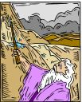
God was leading Moses and all the people to Mt. Sinai.
On the way to Mt. Sinai, they made a camp at a place where there was no water.
The people grumbled to Moses.
They were behaving badly and blaming Moses for all their troubles.
By now, they should have known that God would provide.
They were irritated.
They said to Moses, "Why is there no water to drink? Give us water!"
Moses felt badly that the people weren't trusting God.
Moses asked God, "What am I to do?"
God answered him, "Strike the rock with your staff. I will stand with you and make the water come out so the people can drink."
There was plenty of water for everyone.
Moses named that place Messah which means quarreling.
That's what the people were doing.
Finally they reached Mt. Sanai.
The people camped at the bottom of the mountain.
God told Moses to prepare the people.
God said that He was going to tell them how to live.
When the people were ready, God spoke so everyone could hear:
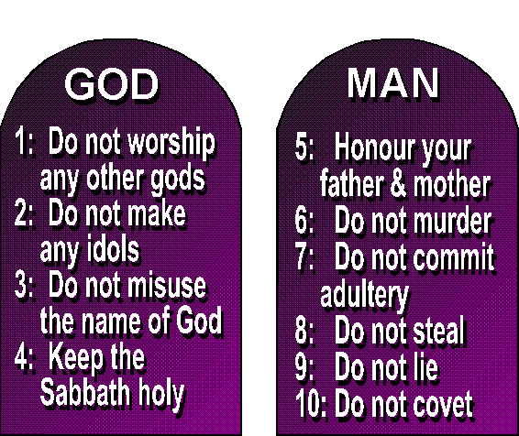

Wow, Can you imagine that!
God spoke His laws so that all could hear!
That's incredible!
These are the 10 Commandments of God.
The first four Commandments tell us how to love God.
The next six tell us how to love each other.

