Samuel
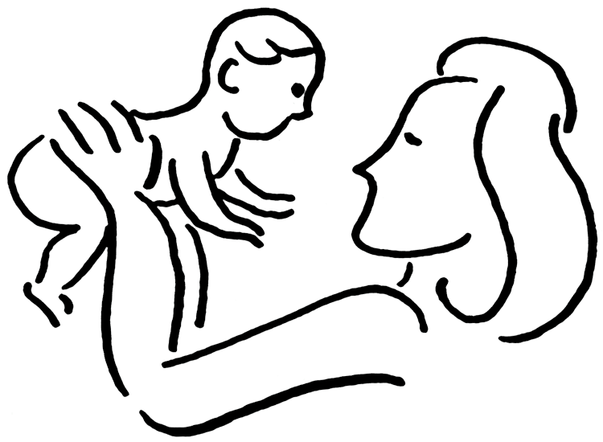
Elkanah and Hannah were married. Hannah was so upset because she had no children.
She prayed hard to God to give her a child. She promised that if God gave her a child, she would dedicate his life to God for as long as he lives. God answered her prayer.
When Hannah's baby was born, she named him Samuel. Samuel means "Asked of the Lord."
When Samuel was about three years old, his parents took him to the temple, for Hannah had promised God that she would leave him in the hands of the Eternal.
They left him with the High Priest, Eli, who trained him in the service of the Lord.
When Samuel was about 12 years old, he was sleeping.
He heard a voice call, "Samuel, Samuel." Thinking it was Eli who called him, he hurried to his room to see what he wanted. Eli said, "I didn't call you. Go back to bed." Samuel went back to bed when he heard a voice calling again. He hurried to Eli saying, "Here I am for you called." Eli told Samuel to go back to bed that he didn't call him.
Samuel heard the voice calling him a third time and hurried to Eli's room to see what he wanted.
Eli knew then it was God calling Samuel.
Eli said, "Go back to bed and if you hear the voice again say, 'Speak Lord, for your servant hears you.' "
Samuel went back to bed and the Lord again called him, "Samuel, Samuel."
Samuel answered, "Speak Lord for your servant hears."
God spoke to him. God made Samuel a prophet. Samuel grew and God stayed with him always.

