Saul
Kish was a wealthy man. He had a son named Saul. Some of Kish's animals were missing and he sent Saul and a servant to look for them. They were gone for many days and couldn't find the missing animals. Saul decided to return home because he didn't want his father to worry. Saul's servant said that maybe they could go to the city of Ramah and ask Samuel where the animals were. Saul agreed and they went to Ramah.

The day before Saul arrived, God told Samuel that he was sending a man and for Samuel to anoint him king. As soon as Samuel saw Saul, the Lord said to Samuel , "This is the man." They were getting ready for a religious festival in the city. As soon as Saul and his servant entered the city, they saw Samuel. Not knowing who he was, Saul asked Samuel for help. "I am the one you are looking for", said Samuel. "Come with me and eat and stay with me tonight. As for the animals that have been lost for three days, don't worry, they have been found." Saul went with Samuel to the festival. Samuel gave him the place of honor at the table and the best food to eat.

When that was over, they went to Samuel's house and talked.
Samuel told Saul that he was to be appointed king.
Early the next morning when Saul was leaving, Samuel walked with him to the edge of the city. There he anointed Saul to be king of Israel. Saul was a bad king just like God said.
He wouldn't do what he was supposed to do. God told Samuel that Saul was to drive the Amalekites from Israel. God told Samuel that Saul wasn't to take a single thing from them.
Samuel told Saul what God had commanded. He told Saul that he was not to take anything from the Amalekites, not even their oxen. Saul did drive the Amalekites from Israel.
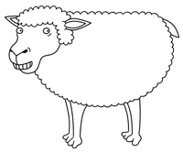
Saul didn't obey God.
He took a man prisoner.
He took the best sheep, oxen and lambs and brought them back with him. God was very unhappy with Saul.
God told Samuel that Saul had disobeyed him and he would remove him as king. Samuel spent the whole night praying for Saul. God told Samuel to go talk to Saul.
The next morning Samuel went to Saul to tell him what God had said. When Saul saw Samuel, he said, "I have done as God asked of me." Samuel said, "Then why do I hear oxen and sheep?"
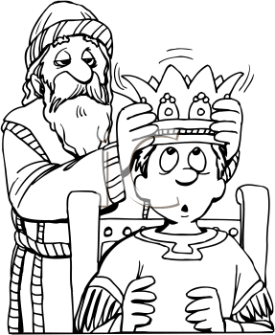
Saul tried to blame everyone else. Saul lied.
He told more lies. Samuel could take no more lies.
Samuel told Saul what God had said to him
Samuel said, "Because you have rejected the word of the Lord, he has rejected you from being king."
Saul was sad.

He can lie to people but he cant lie to God
Samuel was given another task by God.
Samuel was going to anoint another king.
God chose this king. God chose David.
Samuel did as God asked.
He anointed David as the new king of Israel.

