Creation of the State of Israel
1897
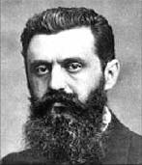

Theodore Herzl wanted to create a Jewish State

1897
Theodore Herzl wanted to create a Jewish State |  |  | Israel and Egypt sign peace treaty

