To Be a Hero?
(Adapted from You Be the Judge 2, Nachum Amsel, Torah Aura Productions, 2002)

You are walking along the street and see a friend of yours being mugged. You know that Jewish law states that one must save someone who is in danger. But you think that by trying to save your friend’s life, you might be putting your own life in danger.

YOU BE THE JUDGE: What should you do?

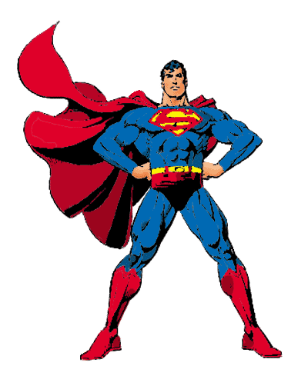

To Be a Hero?
The Interpretations
The question is should a person help a friend who is being attacked? And does the potential danger outweigh the duty, if there is one, to help that friend?
- It certainly is a mitzvah to save a person in danger of dying, as it says, “You shall not stand by the blood of your neighbour” (Leviticus 19:16).

- But there is also a mitzvah to preserve one’s own life, as it says, “And you shall live by them and not die by them.” Therefore, one may not sacrifice one’s own life to save someone else.

- The real dilemma comes in to play when there is a definite danger to someone else and only possible danger to you. Is the obligation to save the person or to keep yourself out of harm’s way?

- There are examples from Jewish history that are inconclusive. For example, Esther puts herself in possible danger in order to save the Jewish people from definite danger.

- On the other hand, God specifically tells Moses to wait until he is out of danger before returning to Egypt to save the Jewish people, who are in definite danger.

- Rabbi David Ben Zimrah (Egypt 16th Century) said that if there is definite danger, one may not even try to save someone. If it is possible danger, one may try if one wishes, but is not obligated. If there is no danger, then one is obligated to save a person in danger.

