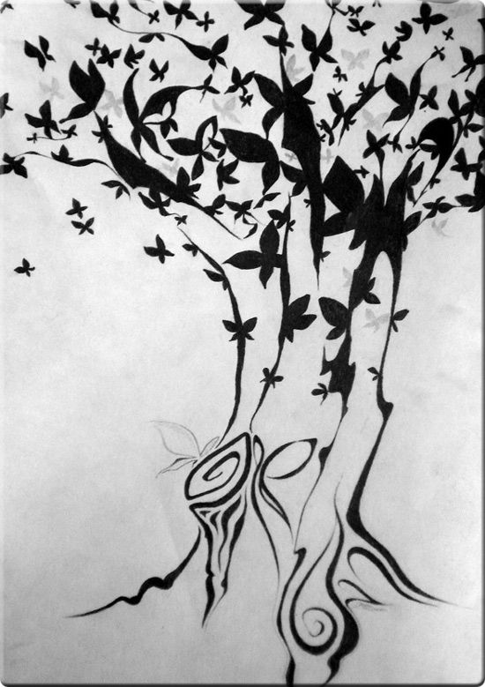

It is a Tree of Life to them that hold fast to it,
And all of its supporters are happy.

Shalom, Shalom.

