Resting on Shabbat

V’Shamru

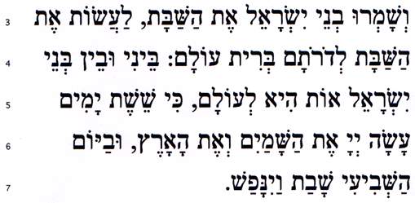

Ve-shamru v'nei Yisroel et ha-Shabbat, la'asot et ha-Shabbat le-doro'tam brit olam. Bei-ni u-vein b'nei Yisroel ot hi le-olam, ki shei-shet ya-mim ah-sah A-do-nai, et ha-sha-mayim ve-et ha-aretz uva-yom ha-shevi'i shavat va-yi-nafash.

The people of Israel shall keep Shabbat, observing it in every generation as a covenant for all time. It is a sign for ever between Me and the people of Israel, for in six days the Eternal God made heaven and earth, and on the seventh day God rested from labour (Exodus 31: 16-17)

