What Happened to the Children of Israel?
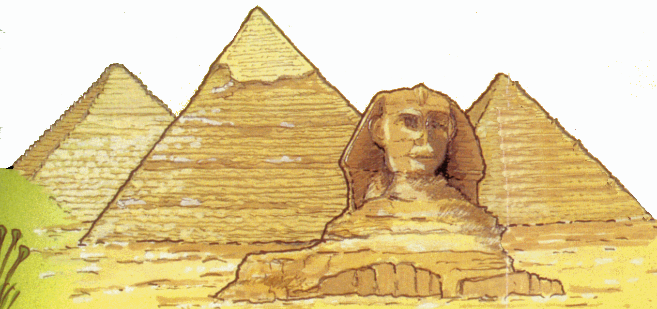
Jacob (who was also known as Israel) had twelve sons, eleven of whom became the tribes of Israel along with Joseph’s two sons Ephraim and Menasseh.¹ Jacob’s descendants lived in Egypt for about 400 years during which time they became slaves. Moses went to Pharaoh and argued for him to set them free. Eventually the Children of Israel were released and so began the Exodus. Because they had been enslaved, they needed to learn how to become a nation with rules and customs. They wandered for 40 years through the Sinai wilderness. The most important event was receiving the Ten Commandments at Mount Sinai which formed the basis for Judaism’s ethical monotheism (believing in one God who inspires us to work for good in the world). Moses saw the Promised Land from Mount Nebo but died before he could enter it. Joshua led the Israelites over the River Jordan and conquered Jericho. The tribes settled in the land of Canaan though Reuben and Gad settled on the east of the Jordan just north of Moab.

For two centuries the tribes built up their own territories and did not have strong connections sometimes fighting one another as well as other kingdoms. The leaders and chiefs of the tribes were the Judges. The Ark of the Covenant was held in Shiloh. Only Samuel was judge over all Israel and the people thought they would be stronger and more able to fight their enemies if they had one king. Saul was appointed king and his reign was one of many battles especially against the Philistines who lived along the coast round Gaza. David became the king when Saul was killed at Mount Gilboa and he soon conquered Jerusalem and made it his capital to where he took the Ark. He wanted to build a temple in Jerusalem but because he was a warrior, the building of the Temple was left to his son Solomon who was the next king. Not only did he build the Temple but other public buildings in a golden age for Israel. The costs were high and the people were heavily taxed. When Solomon’s son came to the throne, the people of the northern tribes rebelled and the kingdom was split into Israel and Judah in the south. Jeroboam, the king of Israel set up shrines at Bethel and Dan so that the people would not have to go to the Temple in Jerusalem for their pilgrimages. Sadly, these shrines were filled with idols and the people followed pagan ways. The prophets arose at this time to challenge the kings and the people. They warned that unless Israel returned to the worship of one God, terrible things would happen.

There was a powerful Assyrian empire to the north of Israel and after 19 kings, the kingdom of Israel was conquered. All the people were taken into exile throughout the Assyrian empire. Perhaps since they had already given up their Jewish ways, it was easy to live like their conquerors and so they lost their identity completely. They are often called the Ten lost tribes of Israel.
Meanwhile in Judah, the country was ruled by the descendants of King David who were sometimes friendly with Israel but mostly at war with it and other countries. According to the Books of Kings, when the leaders were following the Covenant things went well for the kingdom but when they broke the Covenant then the country and the people suffered. In Judah too there were many prophets warning the people to change their ways or God would abandon them. Eventually in 587 BCE, Judah is conquered, Jerusalem and the Temple destroyed and the people taken into exile in Babylon. However, unlike the Assyrian conquest of Israel, many of the Judeans hold onto their faith and their desire to return to Jerusalem. Without this hope and strength of identity, Judaism would have died out two and a half thousand years ago. Luckily, the dream of a return to Zion was kept alive and the rest is history.

¹ Reuben; Simeon, Levi, Judah, Issacchar, Zebulun, Dan, Naphtali, Gad, Asher, Benjamin, plus Joseph’s sons, Ephraim & Menassah. Twelve of these settled in Israel; the tribe of Levi did not acquire territory but became the priests supported by the other tribes.

