Why Should We Recycle?

Every year throughout the whole country our ‘rubbish mountain’ grows. We throw our rubbish into our bins and forget all about it.

Where does it go?
It gets taken to the local ‘landfill’ site and is buried in the ground. We often call the landfill, the rubbish tip.

What happens then?
As it rots it produces an explosive gas called methane and liquid filled with nasty poisons sink into our water sources (rivers), polluting them. This becomes a threat to fish, bird life and plants that grow near the rivers.

Much of the rubbish we throw away can be ‘recycled’ and used again.
- paper
- glass
- metals
- plastic
- kitchen and garden waste can be turned into compost.
- old furniture and clothes can be sent to be resold or re-used.
- Mobile phones
- Ink cartridges from printers.

Each week in this country every household creates huge amounts of rubbish. It’s thought that we throw away.
- 3 kg of paper
- 1.25 kg of glass
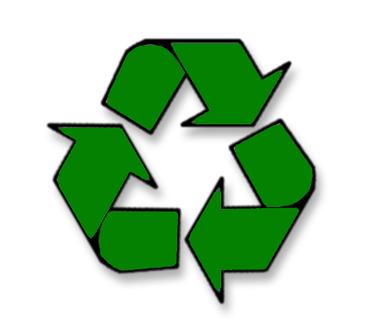
- 2 kg of cans and 1kg of plastic
All this rubbish goes to a local ‘landfill site’.
Why throw it away when we can re-use?
Recycling is good for the environment because
we don’t just keep taking raw materials to make
things but can make things from the rubbish.
Also we aren’t putting rubbish in the ground
that turns into poisons. And, we aren’t taking
up precious land to bury our rubbish in.

