Yom Kippur Story
Once there was a child who loved to tell stories about his friends. Sometimes the stories were true, and sometimes the stories were not quite true. The neighbourhood children did not like their gossiping friend. One day they decided to ask the Rabbi’s advice.
The rabbi heard their complaints, and called the child to his house.
“Why do you make up stories about your friends?” the Rabbi asked.
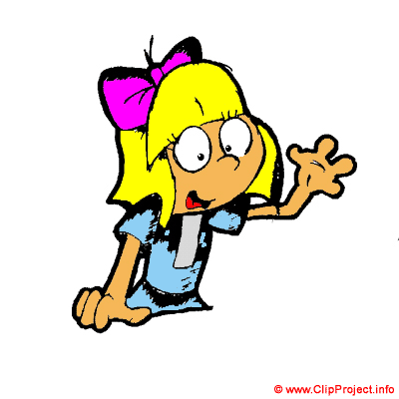
“It’s only talk,” replied the child. “I can always take it back.”
“Perhaps you are right,” said the Rabbi, and he began to talk of other things.
As the child was ready to leave, the Rabbi asked, “I wonder if you would do something for me.”
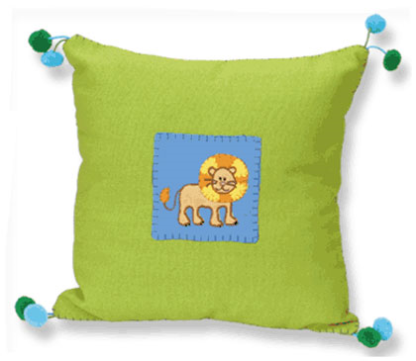
“Of course,” said the child.
The Rabbi took a pillow from the couch and
handed it to the child. “Take this pillow to the
town square. When you get there, cut it open,
and shake out the feathers. Then come back.”
The child was very confused, but agreed to do
what the Rabbi said.
He carried the pillow to the town square and
cut it open.
The heavy wind scattered the feathers across the sky.
The child returned to the Rabbi’s house and told him what he had done.

The Rabbi seemed pleased. He handed the boy a basket and said, “Now please go back to the square, and gather the feathers up again.”
The child gasped. “But that’s impossible.”
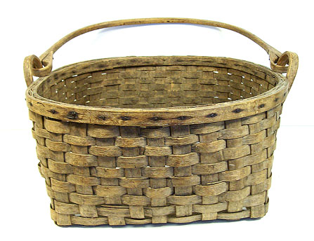
“You are right,” said the Rabbi. “So it is not
possible to take back all the untrue things
you said about others. Be careful with the
words you spread. Once spoken and sent
on their way, they cannot be gathered again.”

