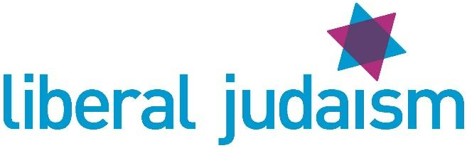
DATA PRIVACY NOTICE – COMMUNITY LEADERS

Liberal Judaism (ULPS)

1. Your personal data – what is it?
Personal data relates to a living individual who can be identified from that data. Identification can be by the information alone or in conjunction with any other information in the data controller’s possession or likely to come into such possession. The processing of personal data is governed by the General Data Protection Regulation (the “GDPR”).

2. Who are we?
Liberal Judaism (ULPS) is the data controller (contact details below). This means it decides how your personal data is processed and for what purposes.

3. How do we process your personal data?
Liberal Judaism (ULPS) complies with its obligations under the “GDPR” by keeping personal data up to date; by storing and destroying it securely; by not collecting or retaining excessive amounts of data; by protecting personal data from loss, misuse, unauthorised access and disclosure and by ensuring that appropriate technical measures are in place to protect personal data.

We use your personal data for the following purposes: -
- To send you information about Liberal Judaism (ULPS) meetings, events, activities, news and updates relevant to your community leadership role
- Where appropriate, to send information about Council meetings, AGMs and other information relating to the governance of Liberal Judaism (ULPS)

4. What is the legal basis for processing your personal data?
Liberal Judaism (ULPS) has identified that it has a lawful basis for collecting and processing your data based on the provision of legitimate interest. The processing relates to contact information for key community leaders with whom there is regular contact relating to your leadership role. A legitimate interest assessment has been conducted as the grounds for this process; this can be viewed on request.
Liberal Judaism (ULPS) will contact all community leaders to clarify your communication preferences on a regular basis.

5. Sharing your personal data
Your personal data will be treated as strictly confidential and will only be shared within the organisation for the purposes of delivering information and services relevant to your role. We will only share your data with third parties outside of Liberal Judaism (ULPS) with your explicit consent; this will be sought on a case by case basis.

6. How long do we keep your personal data?
We retain data on community contacts whilst it is still current; once you cease to be a community leader in the specific role we have collected your data for, we will delete your data.

7. Your rights and your personal data
Unless subject to an exemption under the GDPR, you have the following rights with respect to your personal data: -
- The right to request a copy of your personal data which Liberal Judaism (ULPS) holds about you;
- The right to request that Liberal Judaism (ULPS) corrects any personal data if it is found to be inaccurate or out of date;
- The right to request your personal data is erased where it is no longer necessary for Liberal Judaism (ULPS) to retain such data;
- The right to request that the data controller provide the data subject with his/her personal data and where possible, to transmit that data directly to another data controller, (known as the right to data portability)
- The right, where there is a dispute in relation to the accuracy or processing of your personal data, to request a restriction is placed on further processing;
- The right to object to the processing of personal data
- The right to lodge a complaint with the Information Commissioners Office.

8. Further processing
If we wish to use your personal data for a new purpose, not covered by this Data Protection Notice, then we will provide you with a new notice explaining this new use prior to commencing the processing and setting out the relevant purposes and processing conditions. Where and whenever necessary, we will seek your prior consent to the new processing.

9. Contact Details

To exercise all relevant rights, queries of complaints please in the first instance contact the Data Protection Officer at data@liberaljudaism.org or on 020 7631 9835 or at The Montagu Centre, 21 Maple Street, London, W1T 4BE

You can contact the Information Commissioners Office on 0303 123 1113 or via email https://ico.org.uk/global/contact-us/email/ or at the Information Commissioner's Office, Wycliffe House, Water Lane, Wilmslow, Cheshire. SK9 5AF.

